**Q1: Can you create a basic HTML search form with a text input and a submit button?**



<!DOCTYPE html>

<html lang="en">

<head>

<meta charset="UTF-8">

<meta name="viewport" content="width=device-width, initial-scale=1.0">

<title>Search Form</title>

</head>

<body>

<form action="#" method="get">

<input type="text" name="query" placeholder="Search...">

<button type="submit">Search</button>

</form>

</body>

</html>

**Q2: Generate a search form with filters including a keyword field, a category dropdown, and date range inputs using HTML and basic styling.enerate a search form with filters including a keyword field, a category dropdown, and date range inputs using HTML and basic styling.**

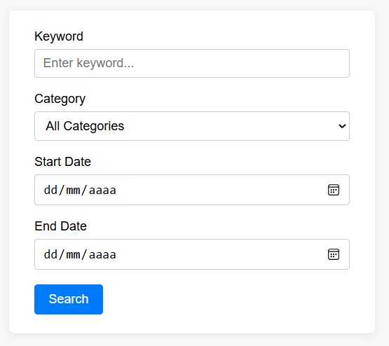

<!DOCTYPE html>

<html lang="en">

<head>

<meta charset="UTF-8">

<meta name="viewport" content="width=device-width, initial-scale=1.0">

<title>Search Form</title>

<style>

body {

font-family: Arial, sans-serif;

background: #f7f7f7;

padding: 40px;

}

.search-form {

background: #fff;

padding: 24px 32px;

border-radius: 8px;

box-shadow: 0 2px 8px rgba(0,0,0,0.07);

max-width: 400px;

margin: 0 auto;

}

.search-form label {

display: block;

margin-bottom: 6px;

font-weight: 500;

}

.search-form input[type="text"],

.search-form select,

.search-form input[type="date"] {

width: 100%;

padding: 8px 10px;

margin-bottom: 18px;

border: 1px solid #ccc;

border-radius: 4px;

font-size: 1rem;

}

.search-form button {

background: #007bff;

color: #fff;

border: none;

padding: 10px 18px;

border-radius: 4px;

font-size: 1rem;

cursor: pointer;

transition: background 0.2s;

}

.search-form button:hover {

background: #0056b3;

}

</style>

</head>

<body>

<form class="search-form">

<label for="keyword">Keyword</label>

<input type="text" id="keyword" name="keyword" placeholder="Enter keyword...">

<label for="category">Category</label>

<select id="category" name="category">

<option value="">All Categories</option>

<option value="books">Books</option>

<option value="electronics">Electronics</option>

<option value="clothing">Clothing</option>

<option value="sports">Sports</option>

</select>

<label for="start-date">Start Date</label>

<input type="date" id="start-date" name="start-date">

<label for="end-date">End Date</label>

<input type="date" id="end-date" name="end-date">

<button type="submit">Search</button>

</form>

</body>

</html>

**Q3: Build a styled HTML and JavaScript form that allows users to search using keywords, category filters, and a date range, and shows a filtered results table dynamically.**

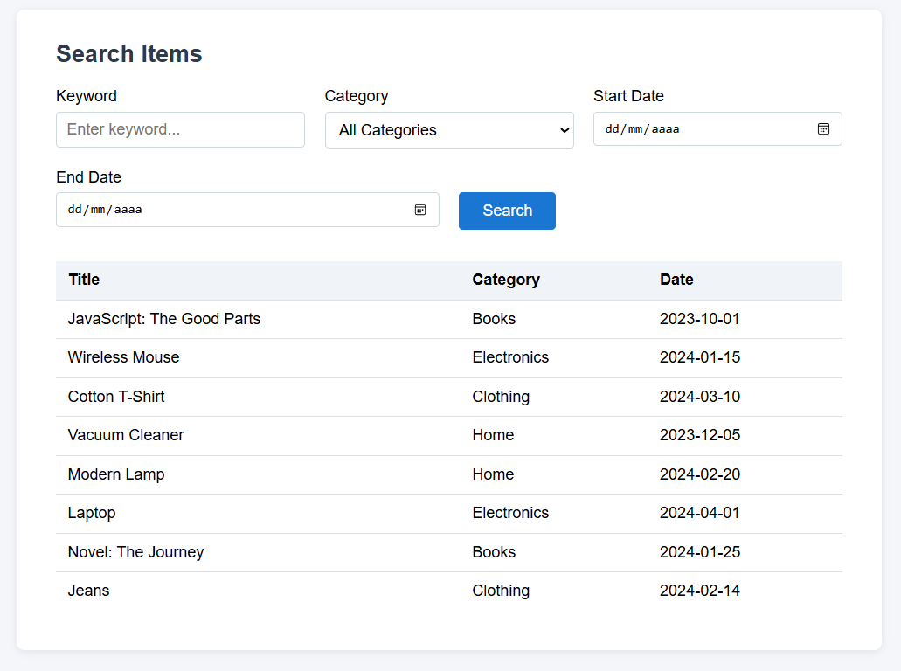

<!DOCTYPE html>

<html lang="en">

<head>

<meta charset="UTF-8">

<meta name="viewport" content="width=device-width, initial-scale=1.0">

<title>Search Form with Filters</title>

<style>

body {

font-family: Arial, sans-serif;

background: #f4f6fa;

margin: 0;

padding: 0;

}

.container {

max-width: 800px;

margin: 40px auto;

background: #fff;

border-radius: 8px;

box-shadow: 0 2px 8px rgba(0,0,0,0.08);

padding: 32px 40px 40px 40px;

}

h2 {

margin-top: 0;

color: #2d3a4b;

}

form {

display: flex;

flex-wrap: wrap;

gap: 20px;

margin-bottom: 32px;

}

label {

font-weight: 500;

margin-bottom: 6px;

display: block;

}

.form-group {

flex: 1 1 200px;

min-width: 180px;

}

input[type="text"], select, input[type="date"] {

width: 100%;

padding: 8px 10px;

border: 1px solid #cfd8dc;

border-radius: 4px;

font-size: 1em;

}

button {

background: #1976d2;

color: #fff;

border: none;

padding: 10px 24px;

border-radius: 4px;

font-size: 1em;

cursor: pointer;

margin-top: 24px;

transition: background 0.2s;

}

button:hover {

background: #1565c0;

}

table {

width: 100%;

border-collapse: collapse;

margin-top: 16px;

}

th, td {

padding: 10px 12px;

border-bottom: 1px solid #e0e0e0;

text-align: left;

}

th {

background: #f0f4f8;

}

tr:last-child td {

border-bottom: none;

}

.no-results {

text-align: center;

color: #888;

padding: 24px 0;

}

</style>

</head>

<body>

<div class="container">

<h2>Search Items</h2>

<form id="searchForm" onsubmit="return false;">

<div class="form-group">

<label for="keyword">Keyword</label>

<input type="text" id="keyword" name="keyword" placeholder="Enter keyword...">

</div>

<div class="form-group">

<label for="category">Category</label>

<select id="category" name="category">

<option value="">All Categories</option>

<option value="Books">Books</option>

<option value="Electronics">Electronics</option>

<option value="Clothing">Clothing</option>

<option value="Home">Home</option>

</select>

</div>

<div class="form-group">

<label for="startDate">Start Date</label>

<input type="date" id="startDate" name="startDate">

</div>

<div class="form-group">

<label for="endDate">End Date</label>

<input type="date" id="endDate" name="endDate">

</div>

<div class="form-group" style="flex: 1 1 100%; min-width: 120px; align-self: flex-end;">

<button type="submit">Search</button>

</div>

</form>

<table id="resultsTable">

<thead>

<tr>

<th>Title</th>

<th>Category</th>

<th>Date</th>

</tr>

</thead>

<tbody>

<!-- Results will be inserted here -->

</tbody>

</table>

<div id="noResults" class="no-results" style="display:none;">No results found.</div>

</div>

<script>

// Example data

const items = [

{ title: 'JavaScript: The Good Parts', category: 'Books', date: '2023-10-01' },

{ title: 'Wireless Mouse', category: 'Electronics', date: '2024-01-15' },

{ title: 'Cotton T-Shirt', category: 'Clothing', date: '2024-03-10' },

{ title: 'Vacuum Cleaner', category: 'Home', date: '2023-12-05' },

{ title: 'Modern Lamp', category: 'Home', date: '2024-02-20' },

{ title: 'Laptop', category: 'Electronics', date: '2024-04-01' },

{ title: 'Novel: The Journey', category: 'Books', date: '2024-01-25' },

{ title: 'Jeans', category: 'Clothing', date: '2024-02-14' },

];

const form = document.getElementById('searchForm');

const resultsTable = document.getElementById('resultsTable').getElementsByTagName('tbody')[0];

const noResultsDiv = document.getElementById('noResults');

function filterItems() {

const keyword = document.getElementById('keyword').value.trim().toLowerCase();

const category = document.getElementById('category').value;

const startDate = document.getElementById('startDate').value;

const endDate = document.getElementById('endDate').value;

let filtered = items.filter(item => {

let matchesKeyword = !keyword || item.title.toLowerCase().includes(keyword);

let matchesCategory = !category || item.category === category;

let matchesStartDate = !startDate || item.date >= startDate;

let matchesEndDate = !endDate || item.date <= endDate;

return matchesKeyword && matchesCategory && matchesStartDate && matchesEndDate;

});

renderResults(filtered);

}

function renderResults(results) {

resultsTable.innerHTML = '';

if (results.length === 0) {

noResultsDiv.style.display = 'block';

return;

}

noResultsDiv.style.display = 'none';

results.forEach(item => {

const row = resultsTable.insertRow();

row.insertCell(0).textContent = item.title;

row.insertCell(1).textContent = item.category;

row.insertCell(2).textContent = item.date;

});

}

form.addEventListener('input', filterItems);

form.addEventListener('submit', filterItems);

// Initial render

renderResults(items);

</script>

</body>

</html>